User Manual

Contents

Introduction 1

Installation Guide 2

How to Use 2

Creating cards 2

Viewing Cards 5

Using the flashcards 6

Custom Decks 6

Random decks 7

Statistics 8

Deck Selector 8

Overall Statistics 9

Badges 9

Options 10

Graph 11

Equation Form 11

Backup 13

# Introduction

This manual will tell you how to install and run the maths flashcard program. It will also explain how to use each sections , and show some error messages that may appear and how to continue using the program after these have happened.

The program is designed to combine maths tools, with a flashcard program as well as generating questions on a few A2 maths topics. It can be used by anyone who wants a flashcard program, but is more specific and relevant if you do A2 maths.

The application allows the user to create packs, decks and cards with four different kinds of flashcard. These can then be viewed and run in either a timed mode or infinite mode. The program keeps track of card statistics and uses this to generate a order of cards seen that should give you cards that you find harder. These statistics are also tracked to deck, pack and overall level and can be seen as bar chars throughout the program. Badges are awarded for doing aspects of the program such as getting a card correct a set number of time, these can all be viewed so you can see what's been unlocked. The application also has a graph which will accept a function in the form nY+k= f(x) , (where f(x) is a function of X containing only polynomials, ln ,log, trig, exponentials and nested brackets) and will a graph with that function. ( More detail on graph form is found in the last section)

# Installation Guide

1. Unzip the folder
   1. Right click on the folder and click 'Extract All', this should bring up a menu asking where you want the folder to be extracted to. Choose anywhere you like.
2. Open the extracted Folder, and run 'AccessDatabaseEngine'.
   1. This is to get the required software for the program.
   2. When running it follow the on screen instructions, if it says you already have the software you can close the window and move on to step 3.
3. The program is now ready to be run through 'PMathsFlashcard'
   1. This will run the program, and should be clicked every time you want to run it.

# How to Use

After installing the program you can now run it by clicking on PMathsFlashcard, here are some instructions on how to use each section of the program.

## Creating cards

Click The 'Create Cards' Button to start making new cards in an existing deck, or in a new one.

If you want to add cards to an existing deck, and pack then select the deck, and pack you want by checking the box and clicking continue (as shown below).

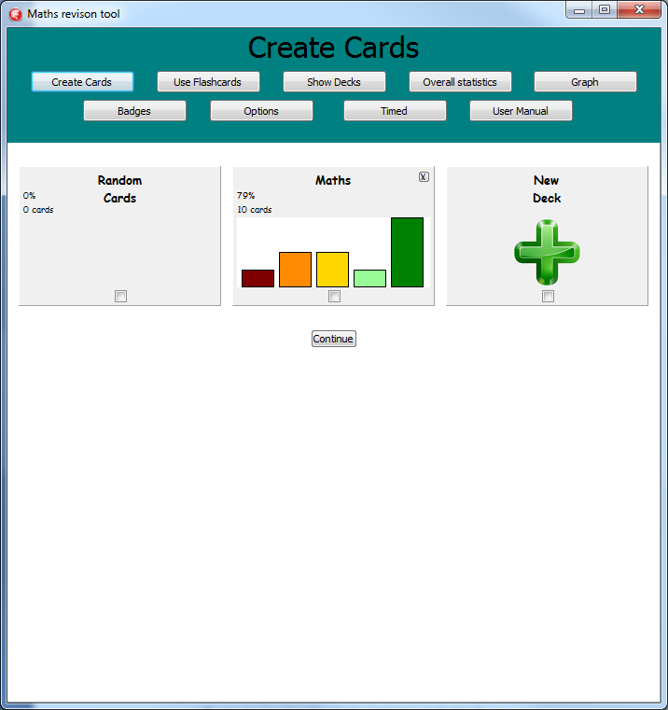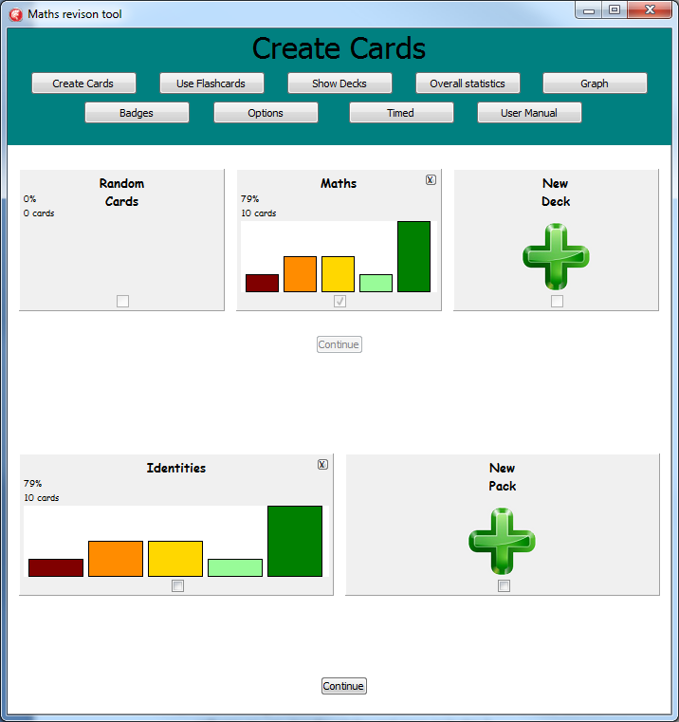

If you want to create a new pack or deck choose the New option. This will then bring you to a menu asking for the name before proceeding to create a pack. The max Deck limit is 5, and the max pack limit is 11. If you try and create a new pack at this point a error message will appear which can be closed, and you will remain on the menu screen.

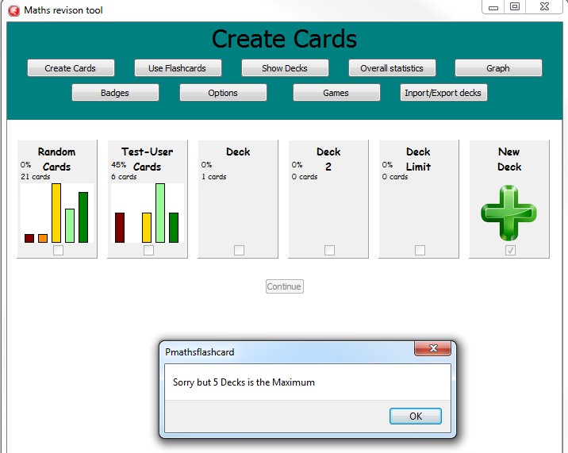

Upon selecting a pack, or creating a new one you will be brought to a new menu.

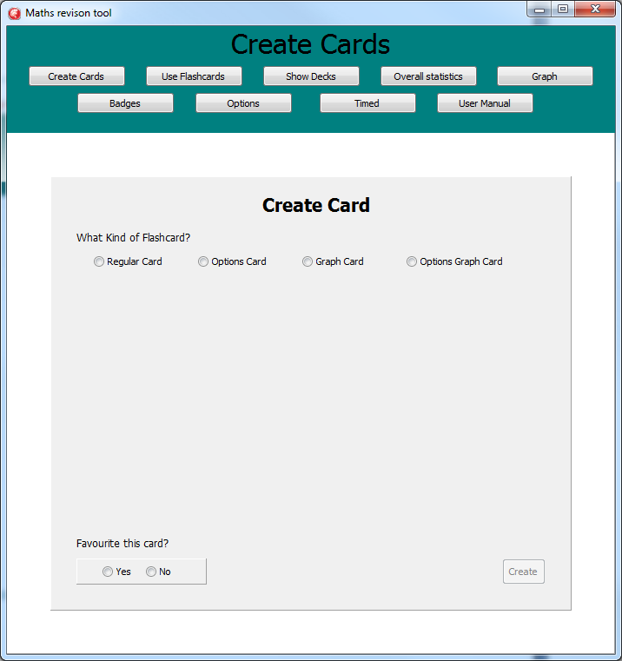

The first thing you must do is select what kind of flashcard you would like to make.

* Regular Flashcard - Has a question, and an answer nothing else.
* Options Card - Has a question and up to six options one of which is correct.
* Graph Card - has a question , graph shown with given question, and one answer.
* Graph Options Card - Has a question and up to six equations of graphs with one being correct.

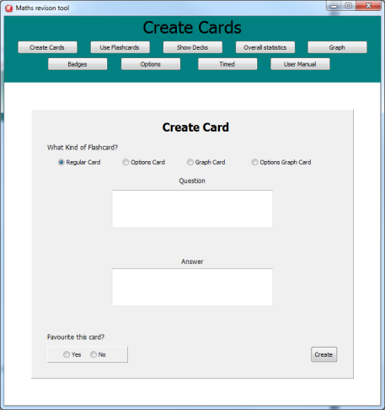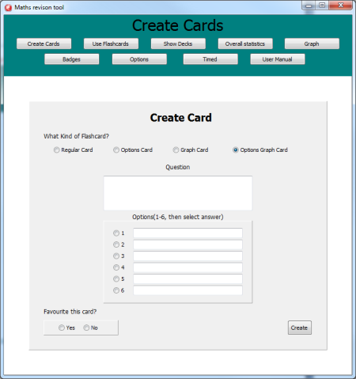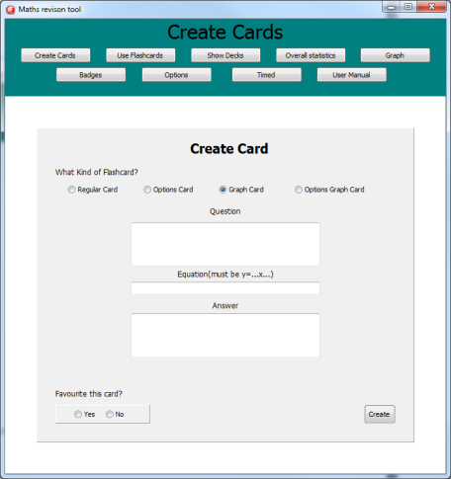

Once you have filled in the data needed for a card, in the edit boxes or by selecting the correct option tick box you click 'Create' and the card has been added, which will also clear all the boxes on the menu. If you don't enter all the data, or enter it incorrectly you will get an error message telling you what's missing when you click create, once exiting this screen amending the mentioned fields will let you create the card.

Note : Graphs equation has to be in the form nY+k= f(x) , where f(x) is a function of X containing only polynomials, ln ,log, trig, exponentials and nested brackets.

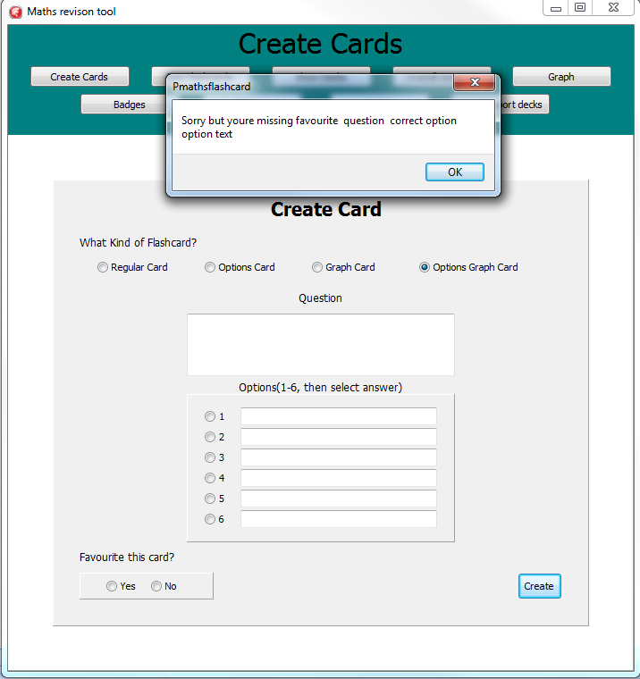

The create a card screen can be exited at anytime by selecting another option on the main bar at the top of the screen.

## Viewing Cards

Click the 'Show Decks' buttons to view the cards in a pack, or in favourites .

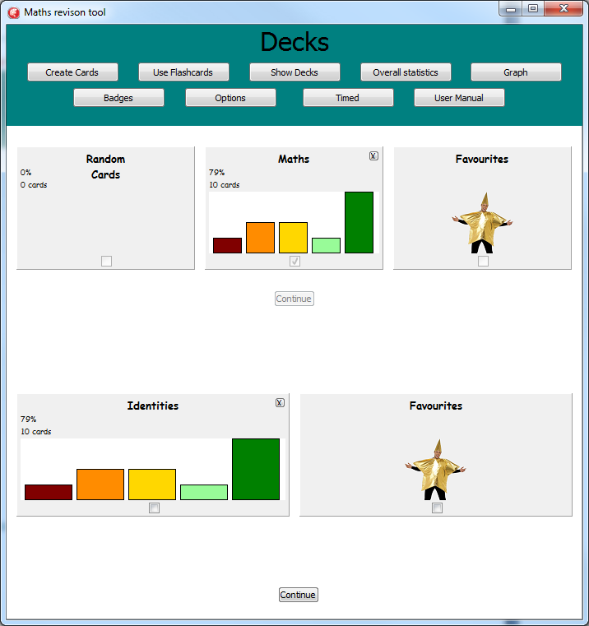

Once again select what pack you would like to view using the checkboxes. This time you can view favourites in a pack or deck. You are also able to view multiple packs at once by selecting multiple before clicking continue. However Packs can only be viewed if they contain cards, if they don't contain any a error message telling you this will appear, and the menu doesn't change.

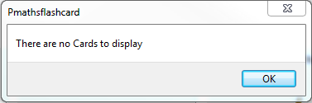

Decks can be deleted if they're not randomly generating by clicking the 'X' on the top right of the deck tile.

Once a pack has been selected to view the cards within that pack will appear on the screen

Shows if the card is a favourite, is gold if it is. Can be clicked to change state.

Title Showing what part of the program you're in.

Click this to bring up the edit card menu.

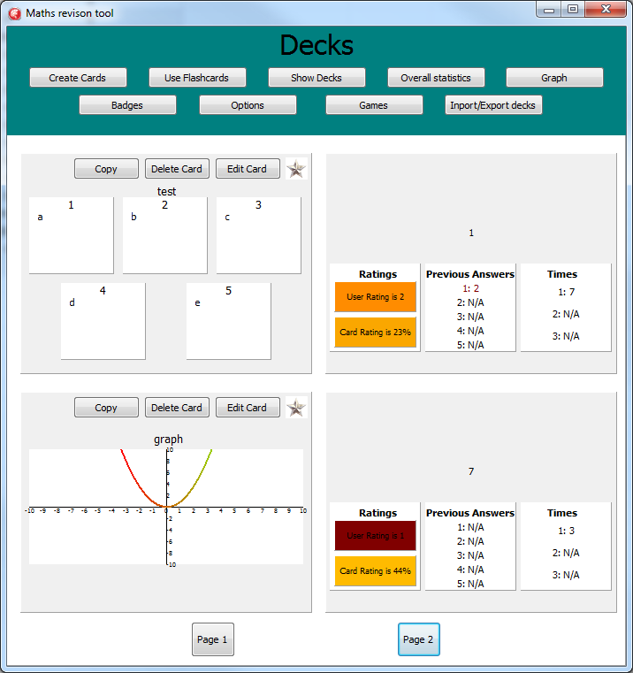

The Question

The Graph for a graph card.

Options on a options card

Clicking this opens up the deck picker menu, for choosing where to copy the card into.

Click this to delete the card, and recreate viewing screen.

The correct Answer

Shows the previous times for running the card

Shows the previous answers. They're red if it was wrong, and green if it was right.

Displays the card rating (0-100%) , and is coloured based on the rating, in a red-green spectrum. Card rating is determined by; Times, user rating, and correct answers.

Displays the user rating (0-5) , and is coloured based on the rating.

Page Navigator , each page shows up to two flashcards

The Picture above explains what each aspect of this menu does.

You can exit this part of the program at any time by clicking on a button in the main bar at the top.

## Using the flashcards

Clicking 'Use Flashcards' will let you see, and use your flashcards , or the generated ones for as long as you like, if you want to see how many you can do in 30 seconds then clicking 'Timed' will allow this.

The deck that's being chosen is selected in the same way as viewing packs, with the same limitations apart from randomised decks can be opened if they have no cards, as some will be generated.

### Custom Decks

Selecting a normal deck will cause the cards you've created to appear, in an order that will show cards which were harder and had a lower rating more often than higher rated cards. The cards llok like this;

Shows if the card is a favourite, is gold if it is. Can be clicked to change state.

Title Showing what part of the program you're in.

Clicking this opens up the deck picker menu, for choosing where to copy the card into.

Click this to bring up the edit card menu.

Click this to delete the card, and recreate viewing screen.

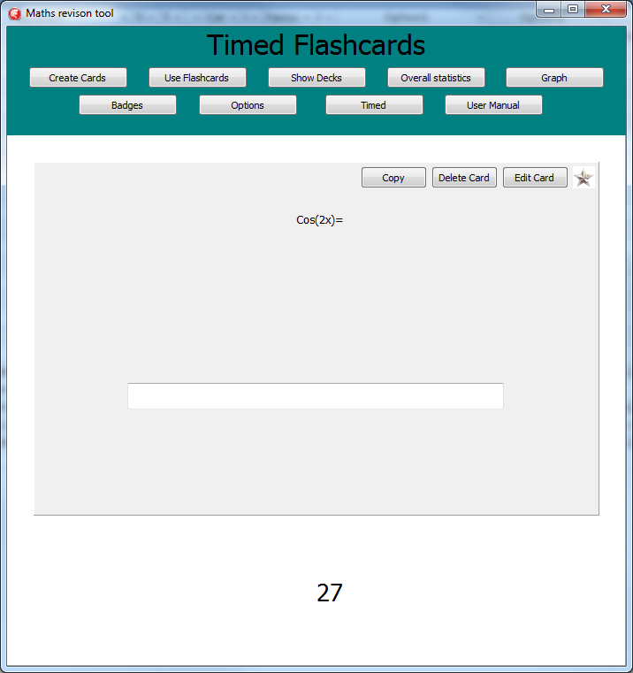 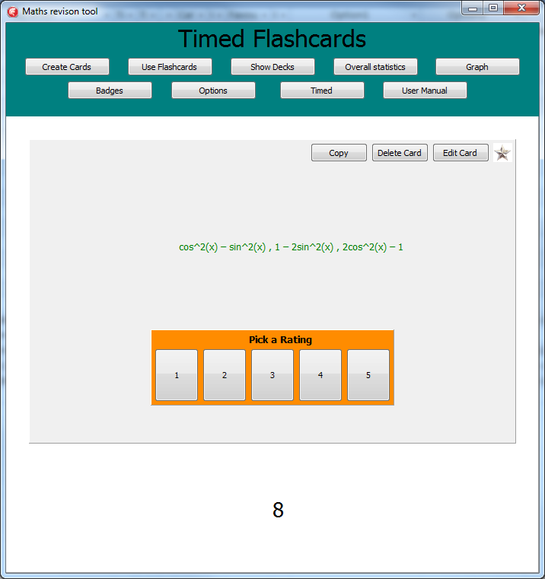

Rating box - Shows the current rating, and upon selecting anew rating a new card will generate and stats will update.

The Answer. Colour indicates if you were correct or not.

The countdown timer, if you're in timed mode.

The Answer box, only shown if it's been enables in the program options, and it isn't an options graph.

The question

To flip the card over click on the light grey background to the flashcard. If an answer is required you won't be able to flip the card until one has been entered in the box or an option has been selected. The card will then flip to the back side of the card , you can now flip as much as you like. The back side shows the correct answer and five buttons. These buttons are for the user rating , the background colour indicated what you've currently rated it ; from red-green, upon selecting a rating a new card will be chosen to be shown to you; stats will update , and the number correct in a timed game will increase.

### Random decks

If you want to get random questions on differentiation, and the modulus function ( which will tests knowledge of transformations) then selecting the 'random cards' deck, and the appropriate pack will allow this.

The program will then create differentiation, or modulus cards with 2-6 options to choose from, or a standard card. These will follow a form when to start with you will see basic questions such as polynomial differentiation, and linear modulus, but as you answer more questions and get a higher pack rating you will start to see questions that involve the chain, product and quotient rule, as well as other functions. Questions that have previously been seen also have a chance to be shown in the same method that a normal deck shows its cards.

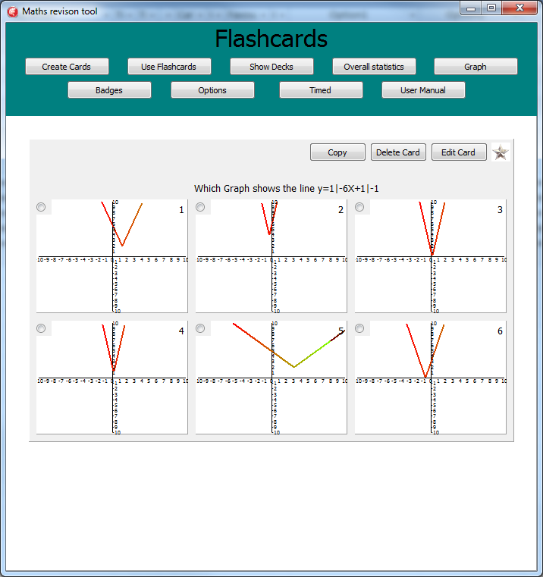

Shown above is a typical beginner modulus card with six options , in this question Option 4 is the correct one.

## Statistics

### Deck Selector

Statistics can be seen throughout the program in the deck selector. 

The bar chart shows the relative % of cards at each user rating (1-5). The tallest bar has the most cards rated that value, and the other bars heights are proportional to this value.

The % shows what that decks average card rating is, which is based off user rating, times, and correct answers.

### Overall Statistics

More comprehensive statistics can be viewed by clicking 'Overall statistics' in the top bar.

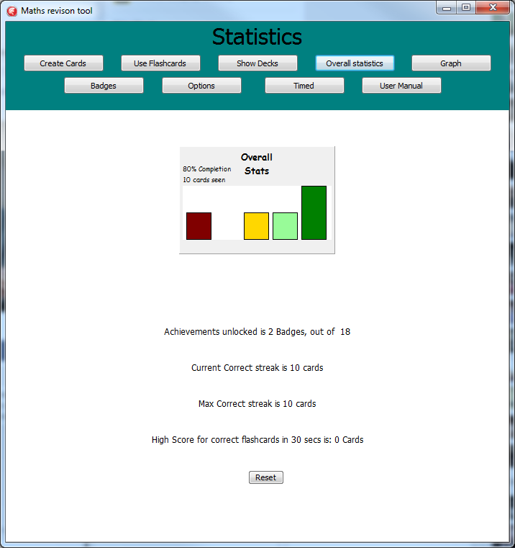

On this page the overall statistics can be seen as a graph in the way as deck statistics were shown. This page will also tell you; how many achievements have been unlocked, correct streaks , and high score on the timed mode.

The whole programs statistics are cleared by clicking the reset button. This will reset all badge progress, card and user ratings, high scores and pack/deck ratings.

### Badges

Upon using enough flashcards you will eventually unlock a badge and get this message.

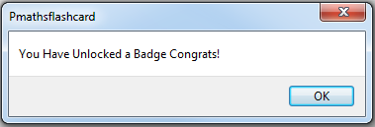

By clicking 'Badges' on the main bar you can view all badges available and your progress towards each of them. 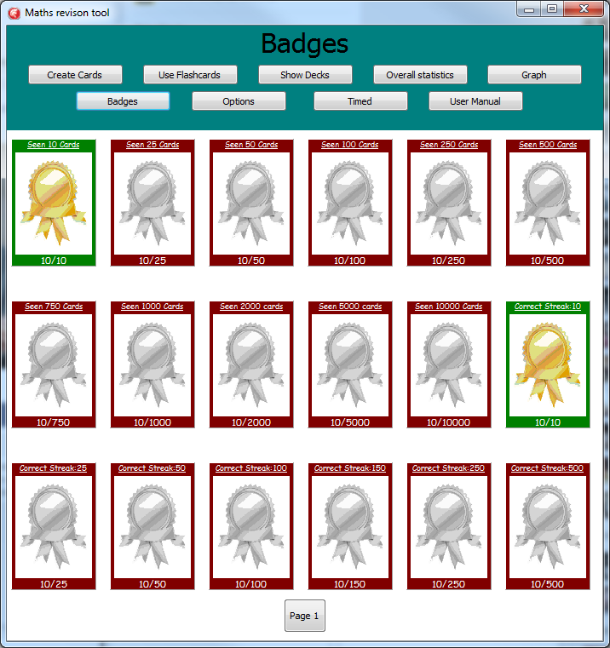

## Options

If you click 'Options' on the main bar you can change a few settings of the program.

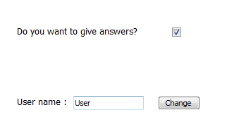

When give answers is on then every normal flashcard and graph card will have an edit box that requires and answer before the card is flipped. It also means that card rating is now taking answers, and previous answers into account when being calculated.

Changing the username will change what name the program has saved your data under.

## Graph

Clicking 'Graph' will open a graph and allow you to draw lines.

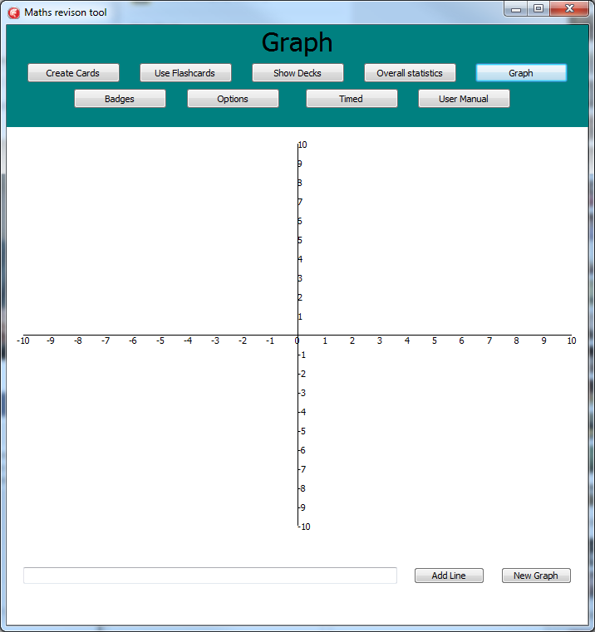

Lines can be added by typing the equation into the edit box and clicking add line. The new graph button will clear the graph so that its blank again.

### Equation Form

The equation must be in the form nY+k = f(x) , where n and k can be in the form i/j or 21.11 etc .

The equations that f(x) can contain are polynomials, ln ,log, trig, exponentials and nested brackets, that can be connected using +,-,/ or *

* Polynomals: eg 3/2X^2+1.2
* Ln: must be in the form nln(f(x)).
* Log must be in the form nlog(f(x))
* Trig: in the form nSin(f(x)) , nSec(f(x)), nTan(f(x)), nCot(f(x)), nCos(f(x)), nCosec(f(x))
* Exponentials: in the form nE^(f(x)) or n^(f(x))
* Nested Brackets: eg n(Polynomial)^2

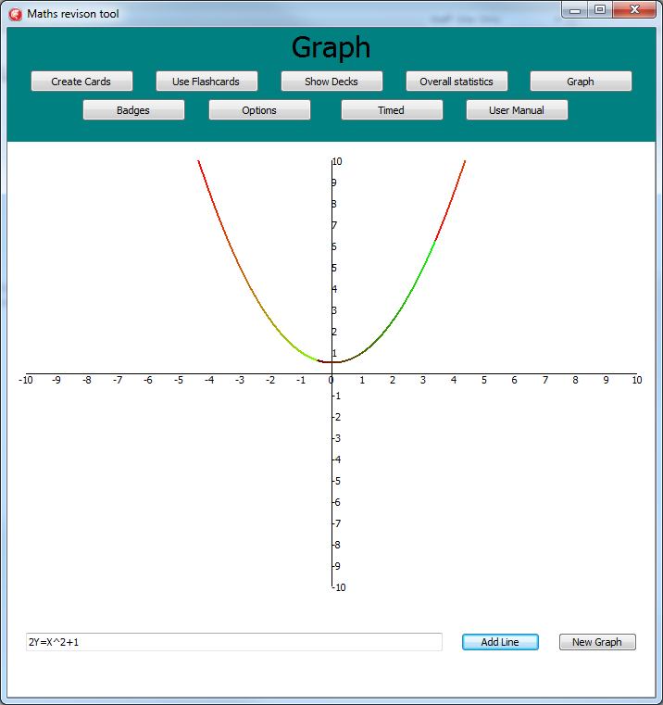 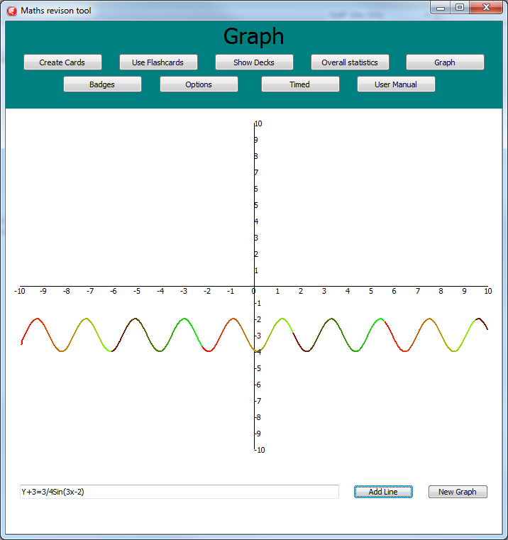

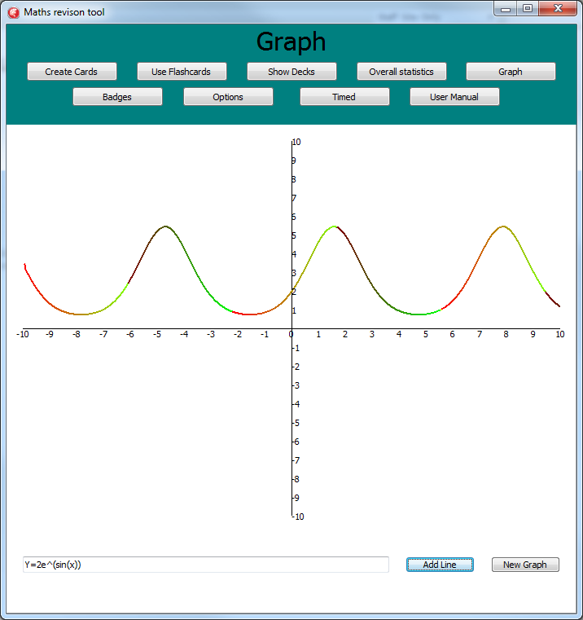 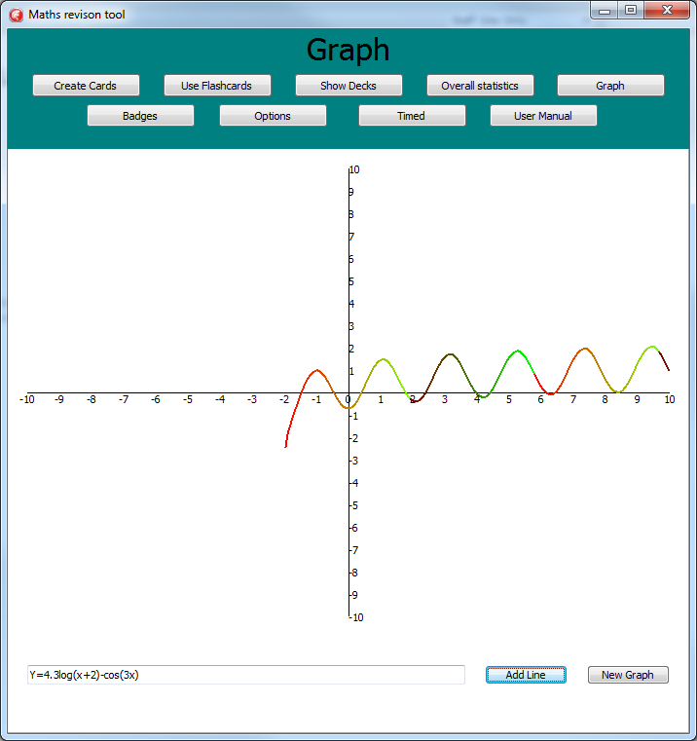 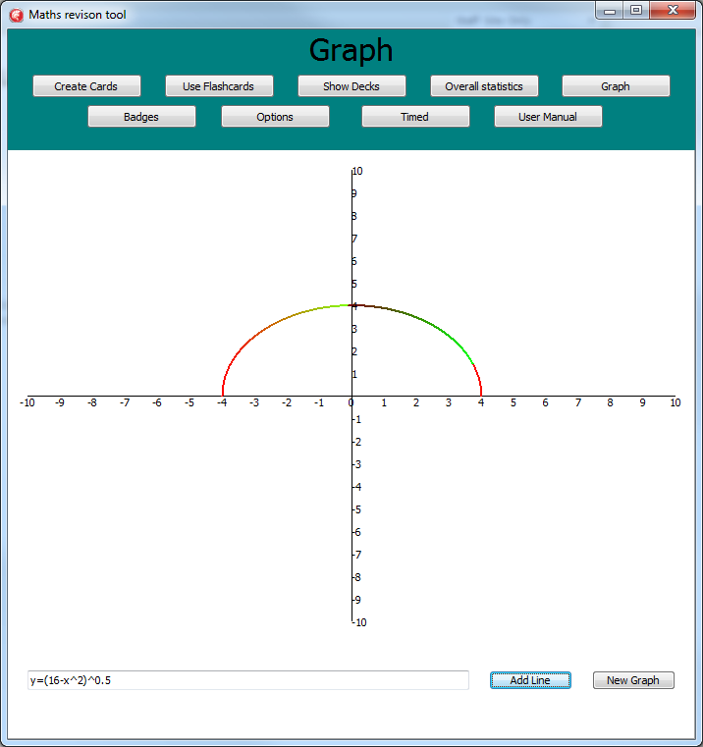 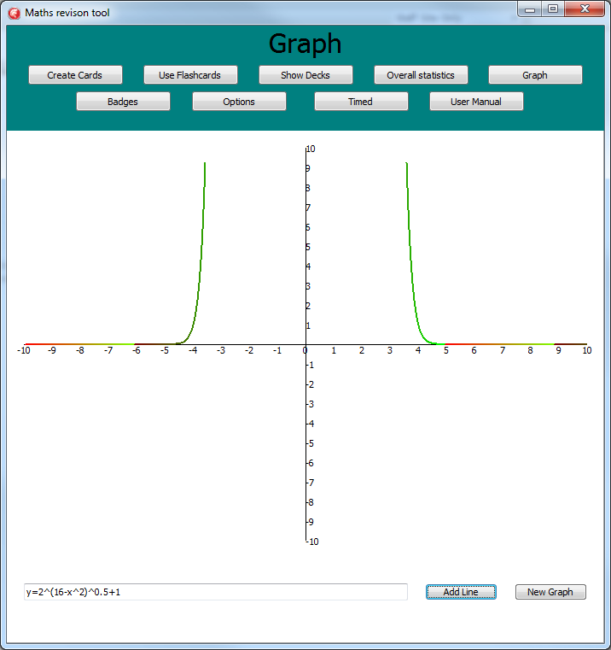

Examples of some possible graphs.

# Backup/Error recovery

If you are worried about backups of the flashcard data, for example if you accidentally delete all your packs. You can copy the' MathsDB1' file elsewhere and you can replace the file if it ever breaks.

If a corrupted card is ever created , you can open the card in view card, close the error message that appears and then delete the card using the delete button.

If you try and run certain parts of the program in a certain situation the program will tell you what you did wrong and stop the program from continuing . Clicking 'ok' on this message will close the window and return you to where you left off on the program. This happens if you try and run/view an empty pack, add a pack/deck when you're at the limit, and enter information incorrectly into the edit/create card window.